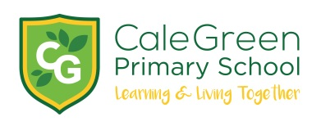
Friday 10th January 2020

Dear Parents and Carers,

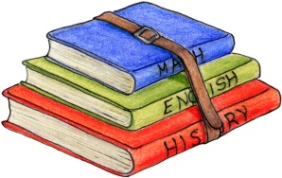

Trips to Edgeley Library

To further promote a love of reading and learn about how to use a library effectively Holly, Hawthorn and Hazel classes will be visiting Edgeley Library during January.

Hawthorn Class- Monday 20th January leaving school at 9.45am
Hazel Class- Tuesday 21st January leaving school at 1.20pm
Holly Class- Wednesday 22nd January leaving school at 9.45am

All children will have their dinner in school as normal and will be walking to the library.

If you have any questions please don’t hesitate to ask.

Yours sincerely,

Mrs Sarah McHugh, Mrs Pijoan, Miss Harris and Miss Falconer

Visit to Edgeley Library
Name of Child:

I give permission for my child to take part in the visit to Edgeley library.

Emergency Contact Numbers:

Medical Conditions:

Signed: Parent / Carer

