Tuesday 11th February 2020
Dear Parents and Carers,

Author Visit- Michelle Robinson
Friday 28th February

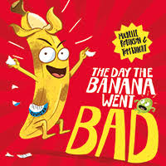

On Friday 28th February at 2pm we will be hosting the author, Michelle Robinson, for the afternoon. It promises to be a lively, fun-filled afternoon as Michelle introduces her new book, “The Day the Banana went bad.”

This will be an exciting session featuring story-telling, a pen and paper challenge and even a little bit of song!

‘Simply Books’ will be bringing copies of Michelle’s brand new picture book for her to sign after the event. It’s a fantastically funny book about celebrating what makes us all different. When ‘Banana’ is thrown into the ‘reject’ bin with the other misshapen fruit and veg he decides that enough is enough -he may be a little bruised but that doesn’t mean he’s any less brilliant!

You can order a signed copy of THE DAY THE BANANA WENT BAD using the form below or bring money along on the day. They will be selling the book at a special price of £6.00.

Kind regards,
Mrs. Sarah McHugh.
Deputy Head teacher

Author Visit - Michelle Robinson - Friday 28th February
Name:

I would like to order a copy of “THE DAY THE BANANA WENT BAD” for £6.00.

I will pay £6.00 on Parent Pay or provide a cheque payable to Simply Books.

Signed: Parent / Carer

