Monday 2nd March 2020
Dear Parents and Carers,
Visit to Our Lady’s RC Church - Thursday 5th March
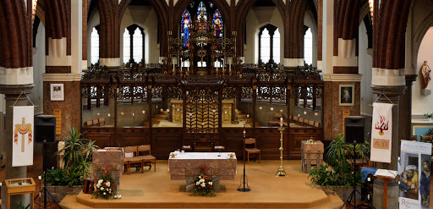

To further support our learning about Easter and Lent, Holly, Hazel and Hawthorn classes will be visiting Our Lady’s RC Church on Thursday 5th March.

We will be leaving school, to make the short walk to the church at 1.10pm after they have had their dinner and will return to school before the end of the school day. If you would like to join us on this visit please let your child’s class teacher.

Kind regards,
Mrs. Sarah McHugh

Visit to Our Lady’s RC Church – Thursday 5th March 2020
Name of Child:

I give permission for my child to visit Our Lady’s RC Church.

Emergency Contact Numbers:

Medical Conditions:

Signed:

