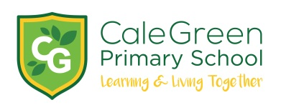
Wednesday 18th March 2020

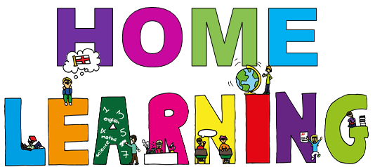

Dear Parents / Carers,

We have recently updated our class pages on the school website so that in the event of school closing, there are core learning activities that children can complete at home.

All children have been provided with a username and password, a ‘home learning’ book and have been shown how to access the ‘Pupil Page’ on the website. If your child is absent and cannot access these pages please telephone school and we will guide you through the process.

What are the core activities should my child be completing if they are well enough to learn at home?

Our children thrive on routine. We hope that all children, where possible, will choose to access and complete the work set each day and hope that this approach will support families to structure days at home more easily for the children.

The school have purchased CGP books for all Year 6 children to support their continued studies in maths, reading, grammar, punctuation and spelling. We know that this class in particular love learning and if they are away from school for an extended period of time these activities will allow learning to continue.

The CGP books should be kept in your child’s bag so that they can be used at home and school on a daily basis.

In the event of school closing, I will set daily activities using the ‘discussion’ tool on the ‘Pupil Pages’ of the website and I will be available online to answer any questions about the learning between 10:00am and 12:30pm each weekday. The discussion tool is a private and secure online area between Year 6, myself and the school administrator.

The books will also be used for homework from next week.

Answers are also included in the books – you may wish to go over the questions with your child once they have completed the set work.

Children will need access to the internet via a computer, tablet or phone. It’s a good idea to allocate a quiet space (if available) to work in and perhaps a drink and a snack. The school will provide pens, pencils, etc as well as a ‘Home Learning Book’.

What other learning activities could my child do home?

There are many other interesting activities children in Year 6 could complete at home that would support their learning. Links to these can be found on the ‘class’ section of the school website and include:

- Reading each day - to an adult if possible
- Spellings (National curriculum Lists are on the website)
- Research project linked to current theme – details on the website
- Guitar practice
- Prior learning revision activities linked to all curriculum areas - details in the class area on the website

If you think that your child will have difficulties accessing the internet at home please contact me at school.

Thank you for your continued support.

Yours sincerely

Mrs Nicola Lewis
Year 6 class teacher

