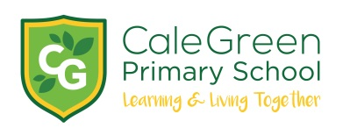
Thursday 19th March 2020

Dear Parents and Carers,
School Closure / Home Learning / Communication
IF PARENTS STILL NEED TO PROVIDE SCHOOL WITH EMAIL ADDRESSES THEN PLEASE EMAIL:
schooladmin@calegreen.stockport.sch.uk
Regular updates will be made on our school Twitter page and by email. All planned arrangements are flexible and may change in response to government advice.
Key Workers
The government issued advice early this morning. In summary:
- Schools have been asked to make provision only for ‘critical workers’ and vulnerable children, the full list of critical workers and further information is available from this link: www.gov.uk/government/publications/coronavirus-covid-19-maintaining-educational-provision/guidance-for-schools-colleges-and-local-authorities-on-maintaining-educational-provision
- Many parents working in critical sectors may be able to ensure their child is kept at home. Every child who can be safely cared for at home should be – to limit the chance of the virus spreading
Initially, school will be open between 8.45am – 3.15pm. A meal will be provided (if necessary) but we do not know if there will be a charge yet.
Staff will provide a range of activities but it won’t be like a usual school day - it will be very much about care and keeping children safe so that key workers (such as NHS staff) can to go to work.
Free School Meals
We have contacted all families whose children are in receipt of Free School Meals. The school kitchen will be open every day to provide a grab bag meal for children in receipt of free school meals between 12.00 – 12.30pm.
We are hoping to quickly move to a voucher system – details will follow as soon as we have them.
Home Learning
Your child’s learning is still important to us, so we’ll continue to help your child to learn!
All class pages on the school website have lots of opportunities for home learning.
Children have been given a username and password which gives them access to the Pupil Area. In the Pupil Area, teachers will start a ‘Discussion Page’ between them and their class. Here the teacher can set work and answer any questions.
Teachers will provide a message to children each morning at about 10.00am and they will be available until 12.30pm to answer any children’s questions about their learning. This is also a good way to get messages to teachers. In the event of teachers being unable to provide remote learning due to illness, details of this will be communicated via the school website.
Children have been provided with a Home Learning Book and stationery. Along with all the website links on the class pages the activities below have been suggested by teachers:
- Reading each day (each child has been given 2 reading books)
- Times tables
- Spellings (lists are on class pages)
- Research project linked to their current theme
- Year 5 and 6 guitar practice
- Phonics for the Early Years and Key Stage 1
Organisations such as the BBC will be providing learning activities at home in addition to those provided by school.
To help keep the children active there are lots of activities on-line including Joe Wicks ‘Kids Workouts To Do At Home’ on YouTube.
Thank you to the teachers for all their hard work in preparation for home learning – your efforts have been truly amazing.
Finally, I cannot thank the whole of the Cale Green community enough for the way you have all pulled together at this time. The kindness, care and support everyone has offered to each other is so heartwarming. The donations of food and money from families and staff for our most vulnerable children have touched us all deeply.
It is a privilege to be a part of, and work for, such a strong and inspiring community determined to help each other – especially in these difficult times. Truly a place where children where children learn and live together.
Please take care everyone and keep safe and healthy.
Yours sincerely
David Marshall
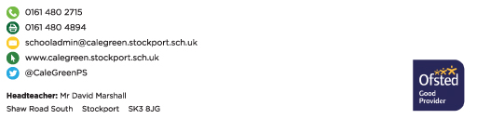
Headteacher

