

Sunday 22nd March 2020

Dear Parents / Carers

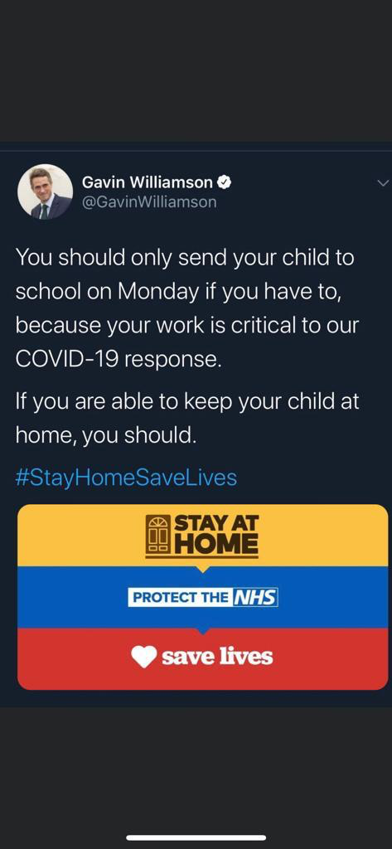

Like many people today I made the decision not to visit my 80-year-old mum on Mother’s Day. As much as I want to see her I want to keep her safe.

My wife has also moved in with her 95-year-old mother in Warrington and will be social distancing for the next 12 weeks to minimise any risk of infection.

**Please keep yourself and your children safe by social distancing.**

There will be a skeleton staff at school tomorrow to reduce the risk of transition of the virus and to promote social distancing.

We have established a rota system of staff to minimise the risk of transmission.

Reducing the numbers of children will reduce the risk of children contracting the virus from other children and adults.

Parents must consider all options to keep children at home, including situations where;

* One parent is working from home
* One parent is not in a critical role
* Where other family members not in at risk groups can provide care

Thank you to parents for doing what is right and saying they are going to work from home whilst looking after their child.

Further information:

* It is not compulsory for key workers' children to attend school; it is an emergency child care provision.
* The role of schools during this time is not to teach but to look after the children so their parents can support others.
* If children can be left at home safely because there is adequate care, then this is what MUST happen - to reduce the spread of transmission.

Our school will be ‘open’ but with the minimum amount of children possible, and the minimum amount of adults possible. This will reduce the amount of people exposed to possible infection.

We will care for all the children of key workers who need our support and the children who most need our care.

**If you now feel that you can arrange for your child to stay at home, then please do not send them to school.**

I understand that you may need to discuss this with your employer, and it may mean that they are in school on Monday until you have done this. I am more than happy to speak to any employer who disagrees with anything I have written; keeping children at home will help the country’s response to COVID19 and potentially save lives.

This message is written with exactly the same desire to help keep your children safe.

I will be in school by 8.00 am tomorrow to answer any, questions you have. Alternatively, please email:

[schooladmin@calegreen.stockport.sch.uk](mailto:schooladmin@calegreen.stockport.sch.uk)

**We showed last week as a whole school community that by doing the right things we can keep all of us so much safer.**

Take care

David Marshall

Please share this letter via Twitter / Facebook.