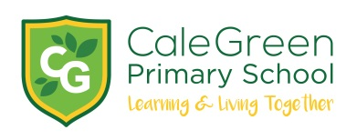

Monday 11th May 2020

Dear Parents / Carers

Yesterday, the government indicated that it might be in a position to begin the phased reopening of primary schools starting with Year 6, Year 1 and Reception from the 1st June.
I’m sure, like me, the announcement yesterday only increased your anxieties and concerns.
In the short term, very little has changed – school is still only open to the children of key workers and vulnerable children – not for those families who wish to return to work.
We all want to get the children back to school however our first priority has to be the safety and health of the children and families as well as staff and their families.
During the next few days more details will be provided by the government as to what is expected of us and how we can manage reopening safely. We will carefully consider how to increase the numbers of children in the school but will only do so on the basis of the safety of children and the staff.
Once again, I cannot stress the privilege it has been to be part of such a strong community response to these incredibly challenging times.
As always, I must stress again that the safety and well-being of the children is our highest priority.
Yours sincerely,
David Marshall
Headteacher

