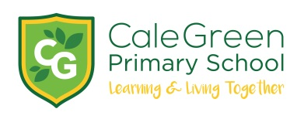
Thursday 14th May 2020

Dear Parents / Carers
Return to School

After the government announcement about a phased return of children to school we are currently in the initial planning process in order to possibly open for children from the Nursery, Reception, Year 1 and Year 6 classes in June.

This presents a great challenge for all schools - especially for us given the layout of our buildings. Any phased return will be manged with extreme caution and care on a step-by-step basis to put as many protective measures in place as possible.

For us to be able to work out what resources we will need to open as safely as possible we would like you to complete a very quick survey as to whether or not you will be sending your child back to school at this time.

We will support every family in their individual decision. There will be no penalty for non-attendance. Please note that brothers and sisters in different year groups will be unable to attend school until we receive further guidance as to how to do so. Currently, this is July at the earliest.

Please complete this survey as soon as possible. There are only 2 questions. The survey will close on Monday 18th May at 1.00pm.

I can only stress again that the safety of the children, the staff and families will be given the very highest priority during this planning process.

https://www.surveymonkey.com/r/JPMZSMX

Yours sincerely,

David Marshall

