Tapestry: How to reset your password

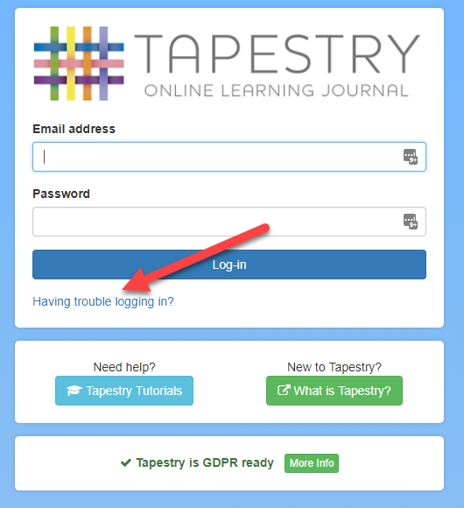

1. Go to www.tapestryjournal.com
2. Click "Having trouble logging in?"

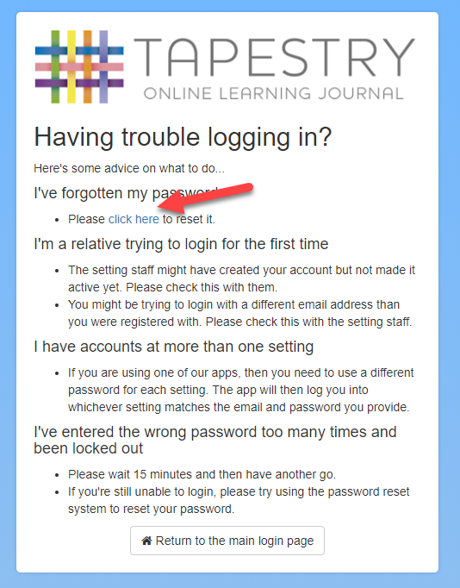

3. Click the link in the "I've forgotten my password" section.

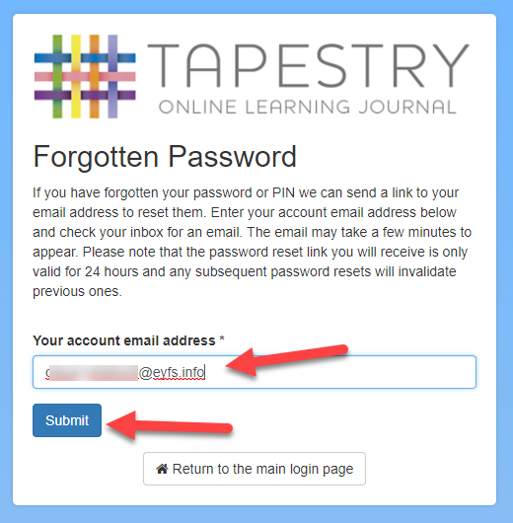

4. Enter the email address that you use for Tapestry
and click "submit".

5. Check your email (you may have to look in your spam/junk mail) –
the email will be called "Tapestry Password Reset".

6. Click the link in the "Instructions" section of the email.
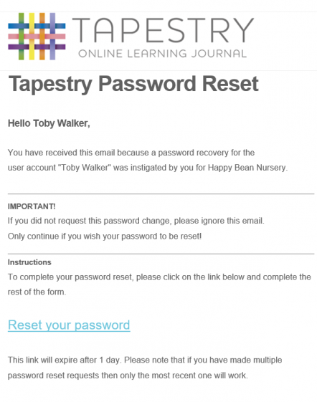
Click this link.
7. Fill in a new password and PIN on the form and click "Submit".
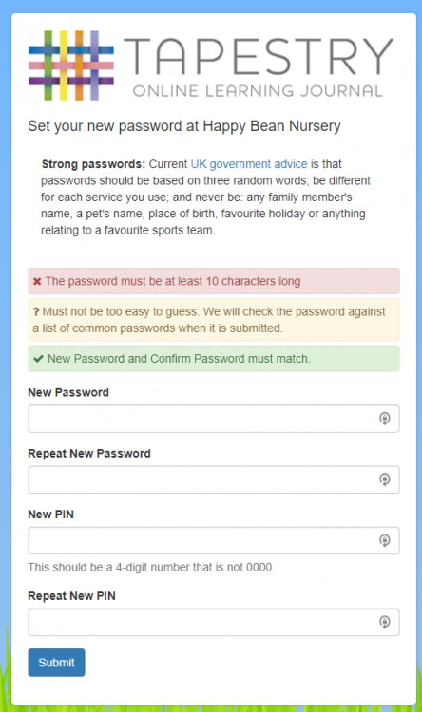

Once you are logged in you will be taken to the main page, where you will be able to see your child's observations.

Please note, it is important to keep this password safe. Some documents the school may wish to share with you are only accessible via the web version of Tapestry, not the app. Please write your password below for future reference:

