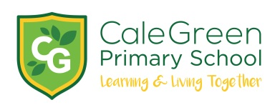
Monday 4th January 2021

Dear Parents / Carers

We have just been informed that schools will be closed tomorrow.

Online remote learning will be available from 9.00am – 3.00pm. The children can access this through the class pages on the school website.

The school will remain open to children of key workers, as was the case in the spring and summer terms. Please contact school if you require this provision.

Provision will also be made for children in vulnerable groups. We will contact families individually regarding this.

There will be no before / after school provision.

Children in receipt of free school meals will be provided with a grab bag, which can be collected between 11.30am – 12.30pm. This will be available every day until a voucher scheme becomes available.

Further information will come out tomorrow.

Best wishes

Mr D.Marshall
Headteacher

