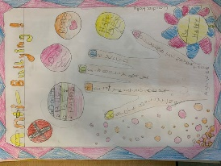
Our Anti-Bullying Policy
Autumn 2022

  - What is bullying?
  - A bully is someone who hurts someone else by using behaviour which is meant to hurt, frighten or upset another person. This behaviour is repeated several times.

  - Bullying is NOT…
When is it bullying?

Several

Times

On

Purpose

We promise to always treat bullying seriously.

When does it happen?

Bullying usually happens when somebody else is different to you or is jealous.

What will happen to a bully?

All staff in school will help to try and solve the problem.

We will follow the Cale Green Code, have conversations with them, talk to their parents and talk to their friends.

  - · accidents
  - · fall-outs with friends
  - · only happens one time
  - · fighting

  - Bullying can be…

  - Emotional:
  - Hurting people’s feelings, leaving you out

  - Physical:
  - Punching, kicking, hitting or pushing

  - Verbal:
  - Being teased, name calling

  - Cyber:
  - Saying unkind things by text, email and online

  - Racist:
  - Treating people differently because of
  - the colour of your skin

Who can I tell?
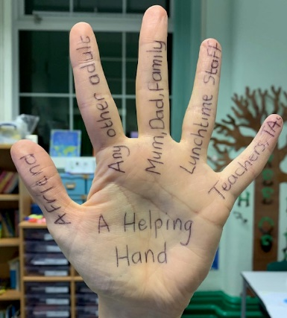

MOST IMPORTANTLY-

If you are being bullied:

Start Telling Other People

Where can I go if I need a friend or play buddy?

If I need a friend or someone to play with at breaktime, I can go and sit on the Friendship bench and someone will come along quickly to help.

I can put a concern in the Worry Box and a Peer Supporter will try and help sort out my worry.
What should I do if I
see someone else is
being bullied?

Tell an adult straight away

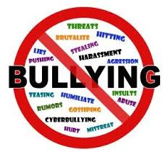 Don’t try and get involved– you
might end up getting hurt or you
could end up in trouble yourself

Don’t stay silent or the bullying
might keep happening

Mrs McHugh, the governors and all the staff will work together. They will work together to:

Make our school a place where
everyone can feel safe and happy.

That means NO bullying allowed!

Help everyone to get on with each other as we believe that everyone has the right to be who they are.

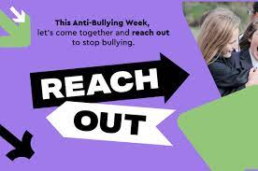
Written by the children of Cale Green Primary School, Autumn 2022

If you are bullied:

DO
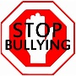
Ask them to STOP if you can

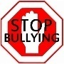
Use eye contact and tell them
to go away

Ignore them

Use Restorative Approaches to
try and deal with the issue

Use the school’s worry box if you
are too worried to speak openly about it

Talk to a friend / trusted adult

TELL SOMEONE and get help
straight away

DON’T
Get angry or be nasty back - try not
to react

Lash out

Think it’s your fault

