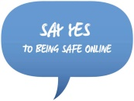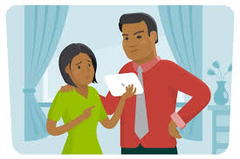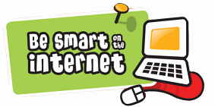

**Who can I tell?**

• Family

• Friends

• Teachers and Teaching Assistants

• Mr. Marshall

• Mrs. Rogers

**How should I**

**behave online?**

**S** safe-secure-sensible

**M** mature-minimize-mindful

**A** appropriate-accountable-actions

**R** rules-restrictions-respectful

**T** trustworthy-tell-thoughtful

**What is e-safety?**

E-safety means being safe when using electronic devices such as tablets and phones.

E-safety is making sure we are safe on the internet and when we are playing games.

**Why do we like the internet?**

• Learn lots of things

• Have fun and help you relax

• Help with your school work

• Stay in touch with friends and family

• Listen to music

**What are the dangers of being online?**

**Cyber Bullying: (some examples)**

Nasty messages and emails, people might persuade you to do something wrong

**Stranger Danger:**

Do we know who we are talking to?

**Bad Language:**

Sometimes when we are online we can see or hear swear words that might upset us

**Content Online:**

Some material online is not suitable for children to look at

**Viruses:**

Some emails can contain viruses

**Racist:**

Calling you names because of the colour of your skin

**When we are**

**online, we should:**

**T** is it true?

**H** is it helpful?

**I** is it illegal?

**N** is it necessary?

K is it kind?

We promise to always treat cyber bullying seriously.

**Who is responsible for**

**E-safety in school?**

Mr. Marshall

Mrs. Horrabin

Miss Bayley

* Every member of staff

YOU!