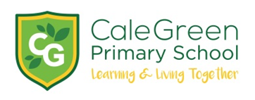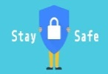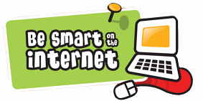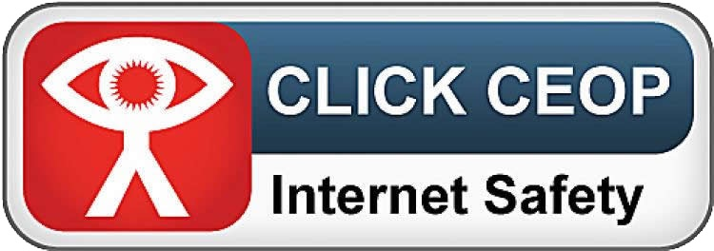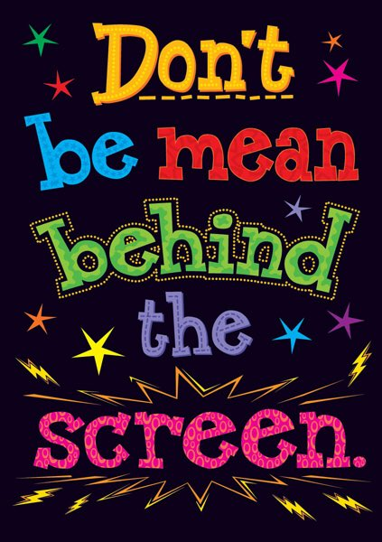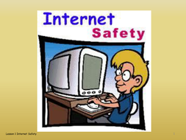

Our Child

Friendly E-Safety Policy

Spring 2021

**This was developed by the children in Key Stage 1 and 2 of Cale Green Primary School**

**If people online are mean or worry me:**

WHAT SHOULD I DO?

• Tell a trusted adult in school

• Tell a trusted adult at home

• Tell a member of the School Council

• Try to stay calm

• Try to ignore the person

• Keep all messages for evidence

• Block them

• Report them to CEOP

**STOP**

**BLOCK   
TELL**

WHAT SHOULD I NOT DO?

• Do not keep worries to yourself

• Do not be unkind or nasty back

• Do not get angry or upset

• Do not give personal information

• Do not share other people’s info

• Do not delete messages

• Do not open Pop-ups

• Do not open websites with a red padlock, only use green ones

**What does our school do to keep us safe online?**

* We have regular online safety lessons
* We accept the online safety rules when we turn on devices
* We have a filtering system and forensic tracking
* We use carefully selected APPs and websites
* We learn about keeping our passwords safe and secure.
* We follow the rules for when we use Google Meet for ‘live’ learning sessions.

Mr. Marshall, the governors and all the staff will work together to:

Make our school a place to learn about being safe online in school and when we are at home.

**Everyone has the**

**right to be safe online**